Family Newsletter
Friday, November 18, 2022
The PATH School
Message from the Executive Director  Learning to read is such an important part of the work we do in schools. The PATH School is committed to following the most evidenced-based practices when it comes to reading, and as result, we have embraced the Science of Reading. The Science of Reading is based on tens of thousands of studies that have been published, and it says that reading comprehension is the product of decoding (the ability to apply knowledge of letter-sound relationships to correctly pronounce words) and language comprehension.  Each week, your scholars in grades 3-8 are taking assessments to help us monitor their progress in reading and mathematics. Some of them will need additional support in these areas, and we will be offering that support in a host of ways. Some of our 3rd and 4th graders are already participating in tutoring 2 days per week. In January, we will begin Saturday School. We may also begin before and after school tutoring to ensure your young people are making the progress necessary to be academically successful for years to come.  In service,  Alicia Hervey  Executive Director | Thanksgiving Holiday  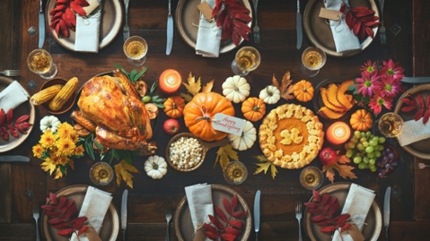  No school Wednesday, November 23rd to Monday, November 28th.  Scholars return to school Tuesday, November 29th.
1st Grade Celebration of Learning  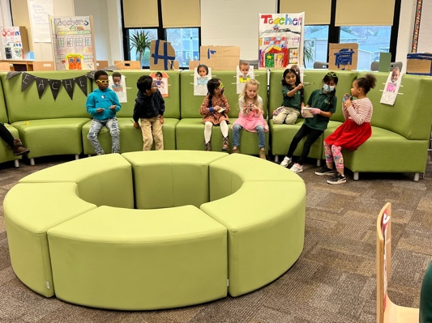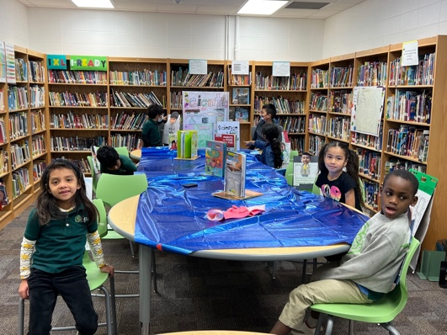 | Looking ahead  - November 23-25, 2022, Thanksgiving Holiday  - November 28, 2022, Professional Development (No school for scholars)  - December 21-January 3, Winter Break

